2017 Brigham’s Christmas Ball
What To Wear!?!?
The Pioneers crossed the plains in wagons and handcarts from 1847-1869, so we are looking for clothing they would have made or mail-ordered shortly after arriving in the Utah Territory. Fashions had a distinct look in 1850 that only slightly changed into the Civil War Era from 1861-1865. The Victorian Era was during Queen Victoria’s reign from 1837-1901. Any of these fashions would be appropriate for the pioneering times at Brigham’s Christmas Ball.

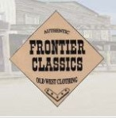
Frontier Classics (Men’s wear for purchase)
Call Diamond-Jim Davis 801-981-8500 to order discount prices
(prices not shown on website)
http://frontierclassics.biz

Victorian Choice (Women’s wear for purchase)
http://www.victorianchoice.com
Recollections (Women’s wear for purchase)
1-800-452-5925
10% Discount Code: SUP10
(watch for more seasonal discounts)
http://recollections.biz

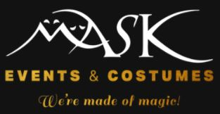
Mask Costumes (Costume Rental)
801-268-8466
15% Discount: Mention SUP Brigham’s Christmas Ball
(call after Halloween to reserve your costume)
http://www.maskcostumes.com

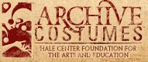
Hale Theater Costumes (Costume Rental)
801-226-8600 Ext 3
http://archivecostumes.org

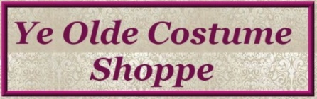
Ye Olde Costume Shoppe (Costume Rental)
801-776-1010
2817 West 6000 South
Roy, UT 84067
http://www.yeoldecostumeshoppe.com

Call Heather 801-484-4441 with any questions or concerns.

